Phone: 402-998-5288
Confidential@TheFirmB2B.com
ID#: CBI030-D

FOR SALE: Road & Utility Excavation – 120% Collateralized
The owner is in his 80’s and could sell his equipment & collect A/R for much more than our price – his staff and legacy are worth more!

Financial Overview  List Price: $15,750,000  Gross Sales  2022 Projected FYE 2021 FYE 2020  $28,000,000 $23,129,882 $18,871,715  Cash Flow  2022 Projected FYE 2021 FYE 2020  $3,290,000 $3,348,236 $2,572,884  - Profit Margin: 14%  - Multiple: 4.7  Current Valuation: 2021 Cash Flow x Multiple = Valuation  $3,348,236 x 4.7 = $15,736,709 |  | Deal Structure  Purchase Price: $15,750,000  85% Buyer + Bank Financing $13,387,500  15% Seller Financing or Equity Roll $2,362,500  Purchase price includes $19 million in assets which results in over-collateralization!  Business Information  Year Established: 50+ years  Location: Evansville, Indiana  Service Area: Primarily Virginia, along with Kentucky and West Virginia  Services: They are a civil contracting company at the top of their field. They are specialists in excavation and utility installation for road projects and large site retail and industrial jobs.  Clients: Municipalities (36%), government (22%), schools (23%), commercial property owners (19%)  Lease: 4,000 sq ft office for $4,000/month which includes 4 ½ acres of land; 1 ½ acre storage area in VA for $1,000/month  Reason for Selling: Retirement, Owner Age  Personnel: 120+, including 3 SVP’s, 8 superintendents, 1 office manager, 1 administrator/billing, and +/- 110 laborers  Seller Training Period: 1-2 years (negotiable)  Current Owners’ Responsibilities: General oversight (by preference), not necessity as owner is 80+ years old.  Growth/Industry Outlook: The services this business offers are deemed essential and the industry as a whole is pandemic proof. The recently passed US Infrastructure Bill is allowing for natural growth in all things construction related.  **Notable: Seller could sell the equipment and cash out the A/R for more than the business price, but due to his legacy and employees in place, he is choosing to sell the business as one cohesive unit so everyone keeps their jobs, and the business can continue to thrive.  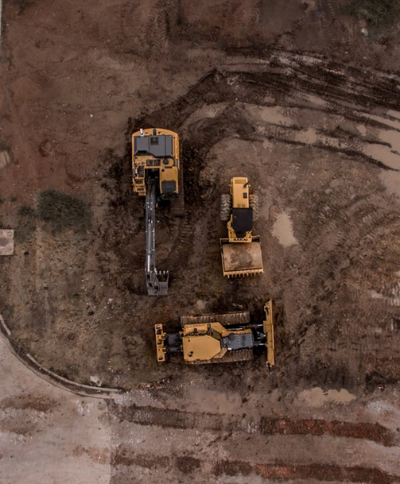  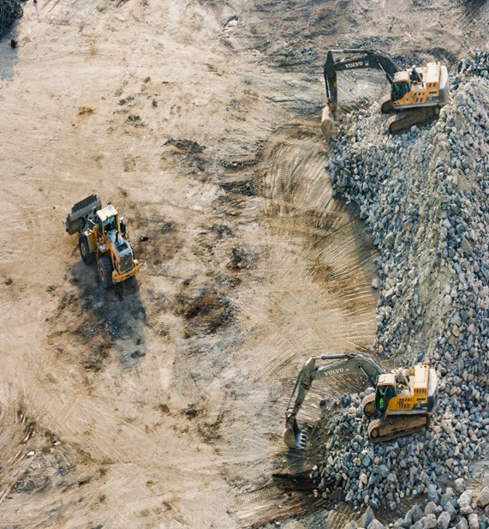
Over $19M in Assets Included in Purchase
Accounts Receivable: $5.4M, $1.6M Retainage
Construction & Transportation Equipment: $10,456,891
Office Equipment & Software: $281,572
Work In Progress: $33M with new bids in the pipeline
**Full equipment breakdown provided in confidential business package – 3rd party appraisal completed June 2022**
*amounts may vary, assets may be depreciated, replacement cost, or fair market value
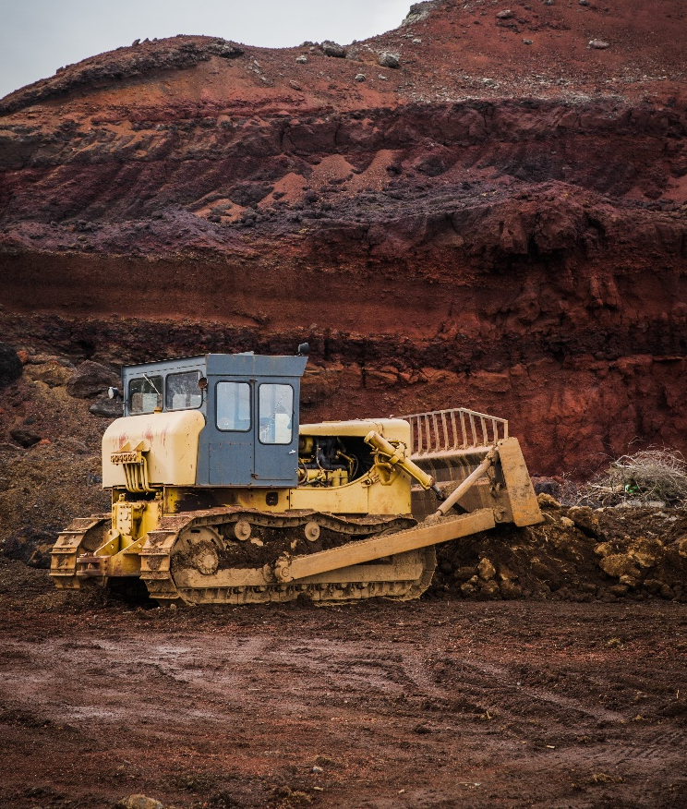

Description

With over $19M worth of assets included in the purchase of the business, the current owner could actually collect more income by selling his equipment than he will be with the purchase of this business. He is choosing to sell his business because continuing to employ his staff and allowing someone to build on the business’s current legacy is more valuable to him than the A/R that his equipment could gather. Thanks to these assets, the purchase of this business is over 110% collateralized. This business is at the top of their field. They are specialists in excavation and utility installation for road projects and large site retail and industrial jobs in their service area of primarily Virginia along with Kentucky and West Virginia. They boast 50% repeat customers. Their client base is made up of 36% municipalities, 22% government, 23% schools, and 19% commercial property owners. Their staff is able to handle a wide variety of clients both in geographic location and in contract types thanks to their size and skill. The team has over 120 members including 3 SVP’s, 8 superintendents, 1 office manager, 1 administrator/billing, and +/- 110 laborers dependent on projects and locations. It is pertinent to note that all staff have signed an agreement to stay on through completion of their current projects, so long as they remain at the same salary and bonus structure.

The current owner performs general oversight as a preference, as he is in his mid-80’s. His passion for the job is clearly contagious, as he has multiple personnel that have been employed for 10+ years, but he’s decided it’s time to retire. Established over 50 years ago, the longevity of this business has resulted in an excellent reputation for high-quality work, completed on time, every time. This long-standing esteem coupled with $33M of work in progress and new bids in the pipeline is manifesting in a projected revenue of $28M for 2022.

Priced to sell at $15,750,000, this excavation company has it all with repeat clientele, profitable contracts, and excellent name recognition. Not to mention the far over-collateralization of purchase with the $19M in included assets. The services this business offers are deemed essential and the industry as a whole is pandemic proof. In addition to this stability, new ownership is also poised to benefit from the increase in business and revenue brought on by the 2021 infrastructure bill which is providing natural growth in the construction industry. As an added layer of faith in the business, not only is the current owner prepared to collect less income from the sale of the business rather than the sale of equipment to keep the business running and the employees working, he is also offering to finance or equity roll 15% of the purchase! We believe that this shows extremely good faith in the future success of the business and mitigates risk to the next owner. There has never been a better time to get into the construction business and, given all of the positive points listed above, this excavation company is ready to capitalize on these incredible opportunities!
- CONFIDENTIAL - Last Revised SF 6/15/2022
The Firm makes no warranties or representation in consideration to the information provided above. All communication regarding this business must occur directly with The Firm Advisors, LLC.
The Firm does not sell real estate. The Firm solely advises on exit strategy.

