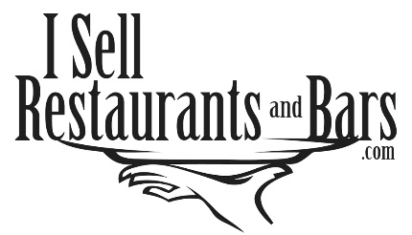
NON-DISCLOSURE AGREEMENT

This agreement is entered into between (the undersigned) and isellrestaurantsandbars.com, a division of Southeast Business Exchange Corporation, referred to as (Agent), in respect to any business represented for sale (Company). This agreement is to protect all proprietary information in which Company or Agent may disclose to the undersigned during the party’s business negotiations directed toward the potential acquisition of Company by the undersigned.
The undersigned agrees not to disclose any of the proprietary information to any third party and to hold all such information in the strictest of confidence unless permitted by written consent of the company or by a court or administrative body of competent jurisdiction. The undersigned also agrees not to use any of the proprietary information for any purpose whatsoever except in connection with the evaluation of the potential acquisition of the Company. If the Undersigned decides not to purchase the Company, then the Undersigned will return all proprietary information to the Agent and not to retain any copy or reproduction, or records of the Company. This includes all business information, customer information, financials, equipment lists, lease agreements, and tax returns.
In the event of the unauthorized use or disclosure of the confidential information of a party or threat thereof, the party will be entitled to seek a restraining order, preliminary injunction, or other appropriate relief to enforce this agreement.

Signature: ____________________________________________ Date ______________
Printed Name: ________________________________________ (Acknowledge Signature)
Address: __________________________________________________________________
City, State, Zip _____________________________________________________________
Phone: ____________________________ Cell Phone: ____________________________
Email: ___________________________________ Fax: ___________________________

